PROJECT REPORT
MEDICAL DIAGNOSIS CENTER BY SERVICENOW SERVICE PORTAL
Team ID: 23891A05C2
Team Member: Shaik Sameera
Date: 15 October 2026
Technology: ServiceNow Service Portal

1. INTRODUCTION

1.1 Project Overview
The Medical Diagnosis Center by ServiceNow Service Portal is a web-based application designed to simplify and manage diagnostic center operations. It provides a centralized platform for patient registration, diagnostic test browsing, appointment booking, test status tracking, and diagnostic report management.
The application is developed using the ServiceNow platform, including Service Portal pages, widgets, application tables, scripts, and workflows. It maintains information about patients, appointments, diagnostic tests, and reports in a structured manner.
Patients can use the portal to explore available tests, book appointments, view their appointment details, and access completed reports. Authorized staff can manage patient records, update test statuses, and maintain report information.

1.2 Purpose
The main purpose of this project is to digitize diagnostic center operations and reduce manual work. It aims to provide a convenient and organized experience for patients and staff.
The objectives are:
To provide a centralized patient registration system.
To simplify diagnostic test booking and appointment management.
To track the progress of diagnostic tests.
To provide access to completed diagnostic reports.
To maintain organized patient and appointment records.
To improve operational visibility through staff and administrative views.
To protect patient information using appropriate access controls.

2. IDEATION PHASE

2.1 Problem Statement
Traditional diagnostic center operations may involve manual registration, appointment scheduling, test tracking, and report distribution. These processes can make it difficult for patients to obtain timely updates and for staff to manage pending appointments and reports efficiently.
Patients may need to contact the diagnostic center repeatedly to check appointment details or report availability. Staff may also face difficulties maintaining consistent records and tracking the progress of diagnostic tests.
Therefore, a centralized digital solution is required to manage patient registration, diagnostic test booking, appointment status, and report delivery. The proposed ServiceNow Service Portal addresses these challenges by organizing the major diagnostic center activities within a single platform.

2.2 Empathy Map Canvas
An empathy map helps understand the needs, expectations, and difficulties experienced by patients and diagnostic center staff.
Empathy Area | Patient Perspective | Staff Perspective
Says | “I want to book a test easily and check my report status.” | “I need to manage appointments and update test progress.”
Thinks | “Is my appointment confirmed? Is my report ready?” | “Which appointments and reports are still pending?”
Does | Browses tests, books appointments, checks status, and accesses reports. | Manages records, updates test status, and uploads reports.
Feels | May feel uncertain when updates are unavailable. | May feel pressured when handling many records manually.
Needs | Easy booking, timely updates, and secure report access. | Accurate records, organized workflows, and clear status tracking.

2.3 Brainstorming
During the ideation phase, several features were considered to improve diagnostic center operations.
- Develop a user-friendly Service Portal.
- Provide a diagnostic test catalog.
- Create a patient registration form.
- Implement diagnostic test booking and appointment management.
- Display appointment status and test progress.
- Provide report management and report access.
- Create separate access permissions for different user roles.
- Use workflow automation for repetitive tasks.
- Provide notifications for appointment and report updates where configured.
- Display operational information through administrative dashboards.
These ideas form the foundation of the proposed Medical Diagnosis Center application.

3. REQUIREMENT ANALYSIS

3.1 Customer Journey Map
The customer journey map describes the steps followed by a patient while using the application.
Stage | Patient Activity | System Response | Expected Outcome
Discover | Opens the Service Portal. | Displays available diagnostic tests. | Patient understands the available services.
Register | Enters required personal details. | Validates and stores the patient information. | Patient record is created.
Book | Selects a diagnostic test and appointment slot. | Creates an appointment record. | Patient can view booking details.
Track | Checks appointment or test status. | Displays the latest saved status. | Patient can monitor progress.
Receive Report | Opens a completed diagnostic report. | Provides report access according to permissions. | Patient can access the relevant report.

3.2 Solution Requirement

Functional Requirements
Functional requirements describe the operations performed by the application.
FR No. | Functional Requirement | Description
FR-1 | Patient Registration | Register patients through a form and store their details.
FR-2 | Diagnostic Test Catalog | Display available diagnostic tests and their details.
FR-3 | Test Booking and Appointment Management | Book tests, view appointment details, and cancel eligible appointments.
FR-4 | Test Status Tracking | Track test progress through Sample Collected, Processing, Completed, and Delivered statuses.
FR-5 | Report Management | Associate diagnostic reports with the appropriate patient and appointment and provide authorized report access.
FR-6 | Notifications | Provide appointment and status notifications when the notification functionality is configured.
FR-7 | Role-Based Access | Provide appropriate access for patients, receptionists, lab technicians, and administrators.
FR-8 | Dashboard and Monitoring | Display operational summaries such as pending appointments and completed tests.

Non-functional Requirements
Non-functional requirements describe the quality attributes of the application.
NFR No. | Requirement | Description
NFR-1 | Usability | The portal should have a simple, consistent, and user-friendly interface.
NFR-2 | Security | Patient information should be protected through authentication, roles, and access controls.
NFR-3 | Reliability | The system should maintain accurate and consistent records.
NFR-4 | Performance | Common operations should respond promptly under normal usage.
NFR-5 | Availability | The application should be accessible whenever the ServiceNow instance is available.
NFR-6 | Scalability | The system should support the addition of more patients, tests, appointments, and reports.

3.3 Data Flow Diagram
A Data Flow Diagram (DFD) represents how information moves between users, application processes, and data stores.

Level 0 — Context Diagram
- Patient
- Registration, booking and status requests
- Medical Diagnosis Center
- ServiceNow Service Portal
- Authorized Staff
- Patient records, test status and report management

Level 1 — Main Processes
- Patient Registration: Collects patient details and stores them in the Patient Table.
- Test Catalog and Booking: Displays diagnostic tests and manages appointment records.
- Test Status Management: Allows authorized staff to update diagnostic test progress.
- Report Management: Stores report information and associates reports with the appropriate records.
- Notifications and Dashboard: Supports status updates and operational monitoring where configured.
The main data stores are the Patient Table, Appointment Table, Diagnostic Test Table, and Report Table.

3.4 Technology Stack
Component | Purpose | Technology
User Interface | Displays portal pages and user interactions. | ServiceNow Service Portal, HTML, CSS, JavaScript
Application Logic | Handles record operations, validation, and business rules. | ServiceNow scripting, GlideRecord, Client Scripts, Business Rules
Workflow Automation | Automates supported application processes. | ServiceNow Flow Designer
Database | Stores patient, appointment, test, and report information. | ServiceNow application tables
File Storage | Stores diagnostic report attachments. | ServiceNow Attachments
External APIs | Not required for the core application scope. | Not applicable
Machine Learning | Not required for the core workflow-management scope. | Not applicable
Infrastructure | Hosts the application and platform services. | ServiceNow cloud platform

4. PROJECT DESIGN

4.1 Problem Solution Fit
- The proposed solution addresses the difficulties associated with manual diagnostic center operations by providing a centralized application.
- Patient registration, test browsing, appointment management, test status tracking, and report access are organized within a single platform. Structured tables help maintain records, while access controls help protect sensitive information.
- The solution is designed to reduce repetitive manual coordination and improve the visibility of diagnostic workflows.

4.2 Proposed Solution
The proposed application uses ServiceNow Service Portal to provide an organized interface for patients and authorized staff.
The main features are:
- Patient registration and record management.
- Diagnostic test catalog.
- Appointment booking and appointment tracking.
- Test status updates.
- Diagnostic report management.
- Role-based access controls.
- Staff and administrative views.
- Workflow automation and notifications where configured.
The application aims to make diagnostic services easier to manage while maintaining consistent records.

4.3 Solution Architecture
The application follows a logical layered architecture within the ServiceNow platform.
Users
Patients • Receptionists • Lab Technicians • Administrators
Presentation Layer
ServiceNow Service Portal, pages and widgets
Application Logic Layer
Scripts, validation, business rules and workflows
Data Layer
Patient • Appointment • Diagnostic Test • Report Tables
Supporting Services
Access controls • Attachments • Notifications, where configured
This architecture separates user interaction, application processing, and data storage logically. All layers operate through the ServiceNow platform.

5. PROJECT PLANNING & SCHEDULING

5.1 Project Planning
The project is divided into four proposed sprints. Story points represent estimated effort and may be updated based on actual implementation progress.
Sprint | Functional Requirement | User Story / Task | Story Points | Priority | Team Member
Sprint-1 | Patient Registration | Register patients with required details. | 3 | High | Shaik Sameera
Sprint-1 | Diagnostic Test Catalog | Display diagnostic tests and details. | 2 | High | Shaik Sameera
Sprint-1 | Patient Management | Manage patient records. | 3 | High | Shaik Sameera
Sprint-2 | Test Booking | Book a test using an available slot. | 3 | High | Shaik Sameera
Sprint-2 | Appointment Management | View appointment details and status. | 2 | High | Shaik Sameera
Sprint-2 | Appointment Management | Cancel eligible appointments. | 2 | Medium | Shaik Sameera
Sprint-3 | Test Status Tracking | Update diagnostic test progress. | 3 | High | Shaik Sameera
Sprint-3 | Report Management | Upload and associate diagnostic reports. | 3 | High | Shaik Sameera
Sprint-3 | Report Management | Access completed reports. | 2 | High | Shaik Sameera
Sprint-4 | Notifications | Provide booking and status notifications. | 2 | Medium | Shaik Sameera
Sprint-4 | Dashboard | Display operational summaries. | 3 | High | Shaik Sameera
Sprint-4 | Access Control | Configure role-appropriate access. | 3 | High | Shaik Sameera

Sprint Schedule
Sprint | Planned Story Points | Duration | Start Date | Planned End Date
Sprint-1 | 8 | 6 days | 16 Oct 2026 | 21 Oct 2026
Sprint-2 | 7 | 6 days | 22 Oct 2026 | 27 Oct 2026
Sprint-3 | 8 | 6 days | 28 Oct 2026 | 02 Nov 2026
Sprint-4 | 8 | 6 days | 03 Nov 2026 | 08 Nov 2026
These dates are proposed planning dates. Actual completion and release dates should be entered after each sprint.

Velocity Calculation
Assume that the team completes 20 story points in a 10-day sprint.
Average velocity = 20/10 =2
Therefore, the average velocity is 2 story points per day.
For a six-day sprint:
2*6=12 sprint days
The estimated capacity is 12 story points per six-day sprint, assuming the same average rate.

Burndown Chart
A burndown chart shows the amount of work remaining during a sprint. It compares ideal progress with actual daily progress.
For example, a sprint beginning with eight story points should ideally reduce the remaining work to zero by the end of the sprint.
Actual daily values should be recorded during project execution. The chart should be updated using the team's real progress rather than estimated results.

6. FUNCTIONAL AND PERFORMANCE TESTING

6.1 Performance Testing
Testing is required to verify that the application behaves as expected and responds appropriately to user actions.

Functional Test Cases
Test ID | Test Scenario | Expected Result
TC-01 | Register a patient using valid details. | Patient record is created successfully.
TC-02 | Submit a registration form with missing mandatory details. | Validation identifies missing information.
TC-03 | Open the diagnostic test catalog. | Available tests and details are displayed.
TC-04 | Book a diagnostic test. | Appointment details are stored correctly.
TC-05 | View the appointment list. | Relevant appointment records and statuses are displayed.
TC-06 | Update the test status using an authorized account. | The updated status is saved and displayed.
TC-07 | Access a completed diagnostic report. | The correct report is available to an authorized user.
TC-08 | Attempt to access a restricted record. | Configured access controls prevent unauthorized access.

Performance Testing Criteria
The application should be evaluated using the following criteria:
Page-loading time for the test catalog.
Response time when retrieving appointment records.
Time required to open a completed report.
Correct behavior when multiple users access the application.
Consistency of records during repeated operations.
Access-control behavior for different user roles.
Note: Actual performance measurements and test results should be added after testing the application. The above criteria describe the proposed test plan, not confirmed results.

7. RESULTS

7.1 Output Screenshots
Insert screenshots from the actual ServiceNow instance under the following headings.
Screenshot 1: Service Portal Home Page / Test Catalog

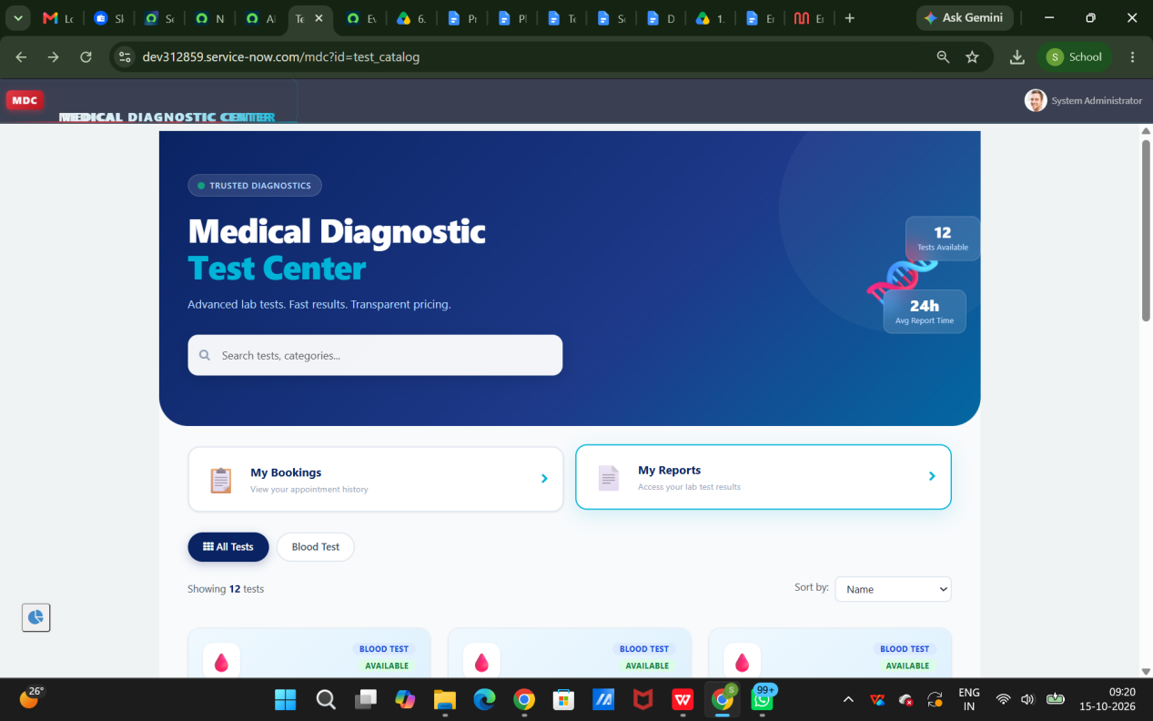Description: This screen displays the available diagnostic tests and provides access to the main portal functions.
Screenshot 2: Patient Registration
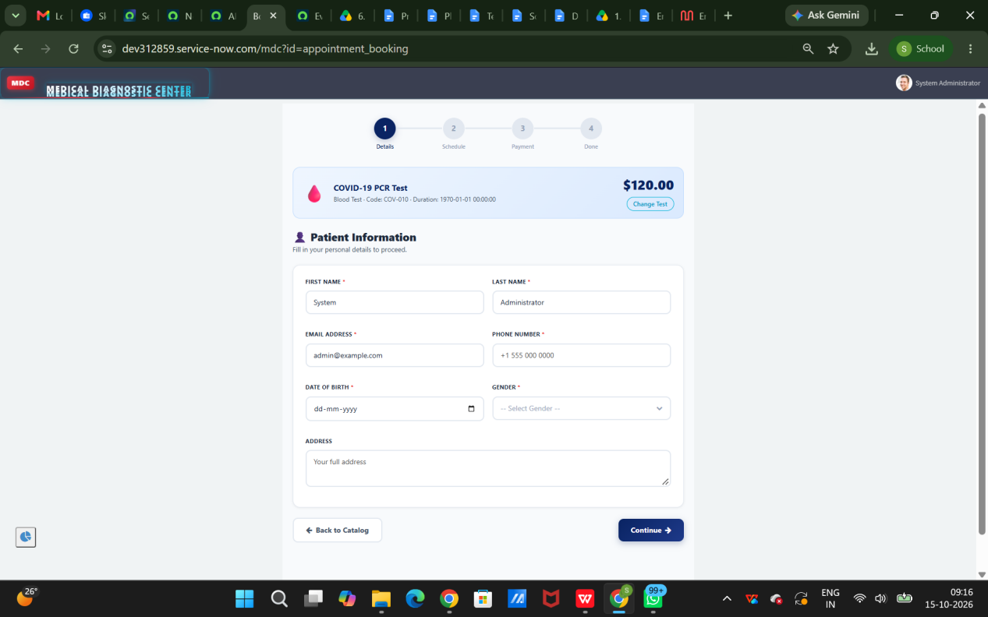
Description: This screen allows users to enter patient details and submit registration information.
Screenshot 3: Book New Test
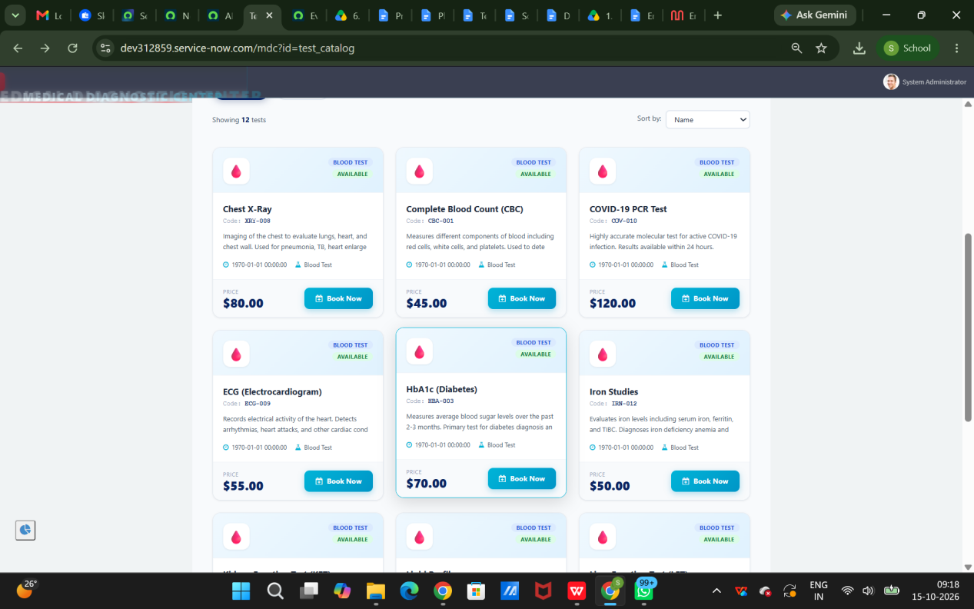
Description: This screen allows patients to select a diagnostic test and book an appointment.
Screenshot 4: My Appointments
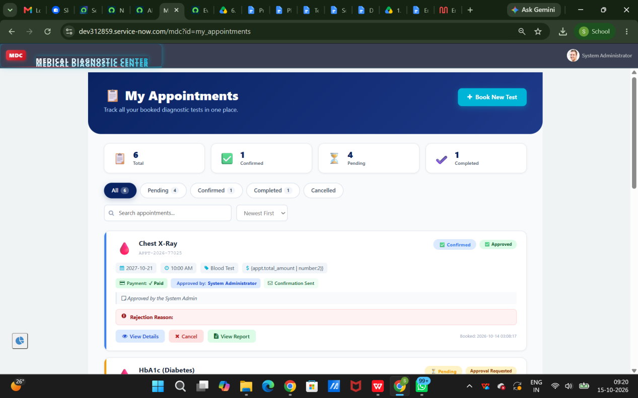Description: This screen displays appointment information and the current saved status of each appointment.

8. ADVANTAGES & DISADVANTAGES

Advantages
- Centralized Management: Patient, appointment, test, and report information can be maintained within one platform.
- Convenient Access: Patients can use the portal to browse tests and manage appointments.
- Improved Tracking: Appointment and test status information can be maintained systematically.
- Organized Records: Structured tables help keep application data consistent.
- Access Control: Role-based permissions can protect sensitive patient information.
- Workflow Automation: Configured workflows can reduce repetitive manual operations.

Disadvantages
- The application depends on the availability of the ServiceNow instance.
- Some functionality requires additional configuration, such as email notifications.
- Advanced booking rules may require additional scripting and validation.
- Access controls must be carefully configured and tested.
- External integrations and payment processing require additional implementation if needed.

9. CONCLUSION
- The Medical Diagnosis Center by ServiceNow Service Portal is designed to organize diagnostic center operations through a centralized digital platform. It brings together patient registration, diagnostic test browsing, appointment booking, test status tracking, and report management.
- The ServiceNow platform provides application tables, portal components, scripting capabilities, workflows, and access controls to support these functions.
- The project demonstrates how a workflow-oriented application can improve the organization and visibility of diagnostic services. The final implementation should be evaluated using actual screenshots, functional test results, and performance measurements from the ServiceNow instance.

10. FUTURE SCOPE
The application can be enhanced with additional features in the future.
- Advanced Appointment Scheduling: Add improved slot availability checks and scheduling rules.
- Automated Notifications: Configure email or other supported notification channels.
- Analytics Dashboard: Provide additional insights into pending tests, report turnaround time, and workload.
- Payment Management: Add invoices and payment tracking if required.
- External Integrations: Integrate with laboratory information systems or other services after reviewing API availability and security requirements.
- Improved Accessibility: Enhance portal navigation and usability for different users.
- Audit and Monitoring: Extend activity tracking and administrative monitoring
These enhancements can make the application more flexible and suitable for broader diagnostic center requirements.

11. APPENDIX

Source Code (if any)
The project implementation may include:
ServiceNow Service Portal pages and widgets.
Client-side JavaScript.
Server-side scripts.
Application tables and fields.
Business Rules and Script Includes, where used.
Flow Designer workflows.
Access Control Rules and role configurations.
Add relevant source-code extracts or exported update sets if permitted by the project submission guidelines.

GitHub & Project Demo Link
GitHub Repository: https://github.com/Sameera1722/medical-diagnosis-center-servicenow
Project Demo: https://drive.google.com/file/d/1lkXPDfKuXWokagitqaOfZwJqM6bnGq2m/view?usp=sharing

REFERENCES
ServiceNow Documentation: https://www.servicenow.com/docs/
C4 Model — Architecture Diagrams: https://c4model.com/
Atlassian Agile Project Management: https://www.atlassian.com/agile/project-management
Atlassian Burndown Charts: https://www.atlassian.com/agile/tutorials/burndown-charts

